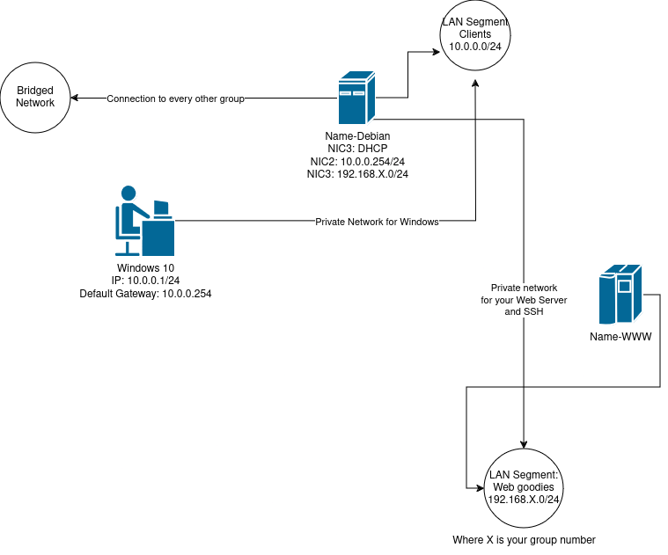

- Network 1: 192.168.10.0/24
  - Network Address: 192.168.10.0
  - Usable Host Range: 192.168.10.1 - 192.168.10.254
  - Broadcast Address: 192.168.10.255
- Network 2: 192.168.20.0/24
  - Network Address: 192.168.20.0
  - Usable Host Range: 192.168.20.1 - 192.168.20.254
  - Broadcast Address: 192.168.20.255
- Network 3: 192.168.30.0/24
  - Network Address: 192.168.30.0
  - Usable Host Range: 192.168.30.1 - 192.168.30.254
  - Broadcast Address: 192.168.30.255
- Network 4: 192.168.40.0/24
  - Network Address: 192.168.40.0
  - Usable Host Range: 192.168.40.1 - 192.168.40.254
  - Broadcast Address: 192.168.40.255
- Network 5: 192.168.50.0/24
  - Network Address: 192.168.50.0
  - Usable Host Range: 192.168.50.1 - 192.168.50.254
  - Broadcast Address: 192.168.50.255

Lab Setup Steps:
Step 1: Configure Virtual Network Editor
- Open the virtualization software and access the Virtual Network Editor.
- Set up two virtual LAN segments corresponding to the diagram:
  - LAN Segment 1: 10.0.0.0/24 (for Debian and Windows 10 VMs).
  - LAN Segment 2: 192.168.X.0/24 (for the Web server and Debian VM).
Step 2: Prepare the Virtual Machines
- Create or configure three VMs: one for Windows 10, one for Debian, and one for the Web server.
Step 3: Network Adapter Settings
- For the Windows 10 VM, set the network adapter to the Windows LAN Segment.
- For the Debian VM, configure three network adapters:
  - One connected to LAN Segment 1 (10.0.0.0/24).
  - One connected to LAN Segment 2 (192.168.X.0/24).
  - One connected to the bridged network (DHCP - IP provided by the upstream network)
- For the Web server VM, set the network adapter to Web Server LAN Segment (192.168.X.0/24).
Step 4: IP Configuration
- Inside the Windows 10 VM, configure the IP settings to match the Windows LAN Segment network.
- Inside the Debian VM, assign the appropriate static IPs for each network adapter corresponding to LAN Segment 1 and LAN Segment 2.
- Assign a static IP to the Web server VM in Web Server LAN Segment.

Enable routing on the Debian machine for routing
Enable routing
sysctl -w net.ipv4.ip_forward=1

Step 5: Testing Inter-VM Connectivity
- Verify that the Windows 10 VM can communicate with the Debian VM's interface on LAN Segment 1.
- Confirm that the Debian VM can communicate with both the Windows 10 VM (on LAN Segment 1) and the Web server VM (on LAN Segment 2).
- Ensure the Web server VM is isolated and can only communicate with the Debian VM but not the Windows 10 VM.

Temporarily assigning an IP
Setting an IP address
sudo ip addr add <IP_address>/<subnet_mask> dev <interface_name>

Setting a permanent IP address
As root
nano /etc/network/interfaces

auto eth0
iface eth0 inet static
address 10.0.0.10
netmask 255.255.255.0
gateway 10.0.0.1
up route add -net 192.168.X.0 netmask 255.255.255.0 gw 10.0.0.254
down route del -net 192.168.X.0 netmask 255.255.255.0 gw 10.0.0.254

Replace eth0 with the actual interface name, and adjust the IP addresses to fit your network. The up command is executed after the interface is brought up, and the down command is executed before the interface is brought down.

Assumptions:
- You are working on a Linux machine within Network 2 (e.g., with an IP address in the range 192.168.20.1 - 192.168.20.254).
- The machine in Network 2 has a gateway to route traffic to other networks. Let's assume the gateway's IP address on Network 2 is 192.168.20.254.

Temporary route (gone upon system restart)
Commands:
# Using ip route (modern method):
ip route add 192.168.50.0/24 via 192.168.20.254

